

Transport Handbook for Clubs & Societies
August 2012

Introduction
If you’re travelling on behalf of a club or society, you’re doing so on behalf of the Students’ Union and the University. Although these guidelines may seem like common sense, please take the time to read through them, and sign the declaration at the back. If you have any queries or would like more specific information, please contact the Student Activities Co-ordinator at the Students’ Union, or e-mail sportsandsocs@gre.ac.uk.

Paperwork
If you’re going on a trip, there are three forms that you need to fill out, with the second form being dependant on what type of transport you plan to use.

First Form: For all transport usage (except for sports fixtures organised by the Activities Co-ordinator) the Trip Registration Form must be filled out. This lets the Students’ Union know where you’re going and how you’ll get there. This should be e-mailed or dropped off to the Student Activities Co-ordinator at least two weeks before the trip in order to conduct health & safety checks and book transport for you if necessary.

Second Form:
If you are travelling by driving your own vehicle, you will need to fill out a Private Car Registration Form. See Section 3 of this handbook for more details.
If you intend on driving a Union vehicle (either owned or hired by the Union), you will need to fill out an Insurance Form so that the Students’ Union can place you on our group insurance policy. This can take up to two weeks to be approved by our insurance company, so please leave plenty of time to do this. See Sections 4 & 5 of this handbook for more details.
If you want to book an external company to hire a vehicle with a driver, then please see Section 6 of this handbook for details of how to do this.

Third Form: Before you leave for any trip, fixture, or event involving transport, you need to ensure you’ve filled out a Passenger List, detailing who is travelling. This can be filled out just before you leave or emailed over in advance, and should be given or sent to the Student Activities Co-ordinator, or either Student Union reception.
Contents

Section 1 – General Awareness | Page 3
Section 2 – Emergency Procedure | Page 4
Section 3 – Using Your Own Vehicle | Page 5
Section 4 – Using a Union Vehicle: Insurance | Page 6
Section 5 – Using a Union Vehicle: Vehicles | Page 7
Can I Drive a Minibus? | Page 8
Section 6 – Hiring a Vehicle with a Driver | Page 9
Section 7 – Public Transport | Page 9
Driver Declaration Form | Page 10
Endsleigh Non Standard Drivers Questionnaire | Page 11
Private Car Registration Form | Page 12
Section 1 - General Awareness

Planning

- Make sure you plan your route (for example, by using a sat nav, Google Maps, or a Route Planner such as the RAC or AA online planners) and allow time for heavy traffic.
- Check that the vehicle you are using is road-worthy – this is your responsibility. When using a Union or hired vehicle a checklist will be provided – make sure you complete it!
- Ensure you have regular breaks every two hours if you’re driving, especially on long trips.
- Avoid driving for more than 4 hours total in one day – if necessary, share driving between two people. It is also usually useful to have a ‘driving assistant’, to help with navigation, passenger control, and changing the music!
- Consult the Highway Code for guidance of your obligations whilst driving.
- Be aware of the height and size of your vehicle, especially for car parks.
- Ensure you do not overload your vehicle beyond the declared gross vehicle weight. For information see section 5 regarding minibus weights.
- If attending a social event the night before driving, be mindful of drinking alcohol. Any alcohol in the system can potentially result in being close to the drink-drive limit the following morning.

Driving

- How you claim fuel costs depends on what type of vehicle you are using, and what purpose the vehicle is being used for. There will be information on claiming fuel costs in Sections 3 & 4 as there are different procedures for fuel costs from your own vehicle and Union/hired vehicles.
- Be mindful of weather conditions which may affect the vehicle you are driving – for example, braking distances for minibuses (especially in wet conditions) are much longer than for a car.
- Take care when performing manoeuvres in the vehicle (if necessary, get another person to assist you).
- Ensure baggage is stored securely in the boot or under seats whilst driving (please note that baggage left unattended in vehicles is not insured).
- You are responsible for reporting any accidents, incidents or near misses which occur whilst you are driving.

Passengers

- Inform passengers of the emergency procedure (see below).
- Ensure that passengers use their seatbelts.
- Park so that passengers have safe exit and entry routes to the vehicle – footpaths are best!
- Ensure that passengers do not distract you or other road users whilst you are driving, for example by:
  - Standing up whilst you drive;
  - Jumping on seats;
  - Shouting or singing loudly;
  - Throwing things;
  - Drinking alcohol or smoking.
Section 2 - Emergency Procedure

General Information
Depending upon where you’re going and what kind of First Aid provision is available, think whether you need to take a First Aider with you. If in doubt, contact the Student Activities Co-ordinator for advice.

We need to be made aware of any accident, incident or near miss – even if it’s minor – so that we can help you. Fill out an Accident Report Form within 24 hours and hand it in to the Student Activities Co-ordinator or Union Reception. You can find these online in the Handbook, in Drivers Packs issued by the Union for Union vehicles, or by asking at the Student Union reception desks. We recommend taking several Accident Report Forms with you when you do any activity!

So any issues after an accident can be resolved as quickly as possible, please ensure you get the following details from any vehicle involved, no matter how minor the accident:
- The person’s name, address and telephone number
- The make, model and registration number of vehicles involved
- The insurance details of other vehicles involved
- The date, time and location of the accident

If there are any witnesses, get their contact details as well. Photo evidence of the accident and any damage caused will also be helpful.

If you have a serious accident:
If necessary, contact the relevant emergency services on 999.
Contact the Students Union on 0208 331 7629/9596 to explain what has happened and get further support. If your trip is taking place outside of the Union opening hours then you should arrange in advance with the Student Activities Co-ordinator for a Students Union staff member to be contactable in case of an emergency.
Do not move casualties unless they are in immediate danger. If the vehicle needs to be evacuated, try to use the doors nearest to the kerb and remain a safe distance from the road.
Do not attempt to put out a fire – there may be toxic smoke.
Do not speak to the media or contact any relatives of people injured. This is the police’s responsibility.
As a result, please also be aware of any information you put online through websites like Facebook and Twitter – often the panic caused by small amounts of information being put out on the internet is worse than the actual accident.

If your driver gets injured:
Please inform the Students’ Union what’s happened immediately. If you can still travel, we will help with recovering the vehicle and getting everyone in the group home. Depending on where you are, we can look to:
- Get a driver to you to drive the vehicle
- Help you get the nearest public transport (whether bus, coach or train)
- Organise a coach or taxi
- Arrange overnight accommodation in extreme circumstances.
Please note that who pays for the recovery costs will be an individual case-by-case decision

Section 3 - Using Your Own Vehicle

If you are driving your own vehicle – whether it is a car, motorcycle, van, etc – and you are doing it for a club or society, we ask that you register your details with the Students’ Union.

This is because of a law that regards corporate manslaughter. The Students’ Union is liable for any injury or death that is caused by vehicles driven by our groups, so we need to ensure that all vehicles used are roadworthy.

To register your vehicle, please fill out a Private Car Registration Form (page 12 of this handbook) and attach copies of:

- Plastic driver’s licence (both sides)
- Paper driver’s licence
- MOT Certificate (or new car registration form if the car is under 3 years old)
- Motor insurance
- Tax disc (a close up photo will suffice)

Fuel Costs

If you drive on behalf of your group, you can claim back the fuel costs at XX pence per mile. You cannot claim fuel costs back for journeys that haven’t had all the relevant paperwork filled in (Private Car Registration Form and Trip Registration Form). We also ask that you inform your insurance company so they are aware you may be doing additional driving – this should not affect your car insurance or your costs.

How Often Do I Need to Register?

If your car insurance, MOT or tax run out during the year, you will need to update us – your registration will run out once one of these documents expires. To update a current registration you just need to send the Student Activities Co-ordinator or Union Reception a new copy of the updated document.
If you continue to update your documents with us then we will keep your registration on file for the duration of time that you are involved in clubs or societies (as shown by your membership purchases). We will remove your details and archive any paperwork when you leave the University or cease to be involved in any Students Union clubs or societies.

Section 4 - Using a Union Vehicle: Insurance

If you wish to drive a Union vehicle, then you need to complete the steps below to be placed on the Union group insurance policy. Even if you have your own car insurance, you must be placed on the Union policy for driving vehicles owned or hired by the Union.
To be placed on the Union group insurance policy you will need to fill in two forms, and provide us with copies your driving licence (plastic and paper parts). You will need to arrange to visit the Union with your licence and hand in:
- A completed Driver Declaration Form (back page of this handbook)
- A completed Endsleigh Non-Standard Drivers Questionnaire (page 11 of this handbook. Note: you do not need to complete the first 3 boxes, just ‘Full Name of Driver’ onwards)
- Copies of the front and back of your plastic licence
- A copy of the front of your paper licence

Please do not return the form to Endsleigh directly – we complete the final steps of the form and send it on behalf of the Union. Please ensure you have completed everything you are meant to, as without all of these items we are not able to place you on the insurance.

Who can be insured?
Due to limitations on our insurance and vehicles, we cannot insure people who are aged under 21, or who have held a driving licence for under 2 years.
There are also additional limitations for drivers who do not hold a UK driving licence – in this situation we need to send the forms to our insurers for their guidance. Drivers who have a large number of penalty points or who have serious convictions may also be denied insurance, however this is at the discretion of our insurers once they have received the forms as per above.

What happens after I hand in the forms?
Once we have all of these items we contact our insurers to find out if you can be placed on the policy. This can take up to two weeks during busy periods, so please get your forms completed as far in advance as possible!
Once confirmation from the insurers is received, we will contact you to confirm the terms of your inclusion on the group insurance policy. The standard excess for the majority of drivers is £250, but this does vary depending on the driver’s age and driving history, and you are responsible for payment of your excess, so please make sure you check your confirmation when you receive it!
How long am I insured for?
Your cover on the group insurance policy is from the day you receive the email with confirmation of the terms of your inclusion on the policy, through to the 31 July that academic year. You can then fill in forms to be included on the policy for the next academic year from 1st August onwards.

Section 5 - Using a Union Vehicle: Vehicles
The Union owns 2 minibuses that are available for club and society use for events, trips and fixtures. Vehicles will only be available to be driven once you have been confirmed as having been placed on the Union insurance, have completed the minibus assessment, and approval has been given for the activity. For any event, trip or fixture that is not organised by the Student Activities Co-ordinator you will need to follow the procedures for events/trips as found in the Sports & Societies Handbooks.

The Minibus Assessment
All drivers are required to undergo an assessment of their driving prior to being allowed to drive the minibus for an activity. These are administered by the Union and are booked by contacting the Student Activities Co-ordinator with details of when you are free during the week to take the test. You will then be contacted by a Union staff member to confirm when the assessment will take place.

The assessment involves a period of time driving with the instructor for you to get used to the handling of the minibus, followed by a practical assessment of your driving and a maintenance walk around the vehicle. Assessments are valid for a maximum of three years.

Minibus Permits.
When driving a minibus for a club or society, you need to display a Section 19 Standard Permit in the vehicle. Permits are displayed on the windscreen of the vehicle and must not be removed or tampered with. We are allowed these permits because the Students’ Union is a not-for-profit organisation, and this is what allows you to drive a vehicle larger and heavier than is usually allowed on a normal driving licence.

Under the rules of a Section 19 Standard Permit, you cannot be paid or rewarded for driving, you cannot drive with a roof rack or trailer, and if you do not have category D1 on your licence then the maximum vehicle weight allowed is 3.5tonnes (or 3500kgs).

Driving Safely and Minibus Weights
Although this will be covered in your proficiency test, please remember that minibuses are larger and heavier than a standard car. You will find that they:
Require a bigger turning circle;
Are slower at accelerating and take longer to brake;
Have reduced visibility when full with passengers; and
Are heavier to drive and manoeuvre, even with power steering.

Please also ensure that you also bear in mind how much equipment you carry. The Students’ Union minibuses which will be available for drivers without category D1 permissions on their licence to drive have a maximum gross weight of 3500kg, which cannot by law be exceeded. Each of these minibuses has a weight of 2444kgs, which leaves 1056kgs (166 stones) as the maximum weight for passengers and luggage. It is the responsibility of the driver to ensure this weight is not exceeded. The weight limit of 1056kgs works out as 14 passengers who weigh 75.5kgs (11st10lbs).

If you think you will be close to this limit, please contact Student Activities and we will try and help with a solution. Do not assume that you will be ok – overloading the minibus could cause a serious accident and it is illegal to drive the vehicle if it is overloaded. The driver of an overloaded vehicle could be fined, prosecuted or have their licence revoked.

Can I Drive a Minibus?
There are a number of rules around the driving of minibuses which can be quite complicated. To try and make it as clear as possible we’ve provided the flowchart below that should help you work out if you can drive a minibus. If this doesn’t help then please get in touch with the Student Activities Co-ordinator for advice.
Yes
Go on to Q2.

Q2 Do I have category D1 permissions on the back of my plastic licence?
Yes – I have category D1 permissions because I passed my test before 1st January 1997.

Once you have been confirmed as covered by the Union vehicle insurance, you can drive a minibus that has up to 16 passenger seats, but may not do so for ‘hire or reward’ and may not tow a trailer.

Yes – I have category D1 permissions because I passed my Passenger Carrying Vehicle driving test.

Once you have been confirmed as covered by the Union vehicle insurance, you can drive a minibus that has up to 16 passenger seats and tow a trailer weighing up to 750kg, provided evidence of passing this test is passed to the Union and a confirmation is received from our insurers.

Q1 Am I aged over 21, and have I held my licence for over 2 years?

No
You are not eligible to drive a minibus as drivers must be aged over 21 and have held their licence over 2 years.
We do not at this time have other vehicles available for use.

No – I do not have category D1 permissions on my driving licence

Once you have been confirmed as covered by the Union vehicle insurance, you are eligible to drive a minibus weighing no more than 3500kgs (usually a 13 passenger seat minibus at maximum), but may not do so for ‘hire or reward’, or tow a trailer. As the minibus weight is a criteria for you being allowed to drive it, you must monitor the weight of luggage and passengers on board as per Section 5 of this handbook.

Section 6 – Hiring a Vehicle with a Driver
The Union can book a minibus with driver or coach for your trip. There are a variety of coach sizes available, from 16 seat minibuses upwards.

In order to request an accurate quote and book the coach for you, we will need to know the following information:

- Name of your club or society;
- Your pick up & drop off point;
- Date & time to be picked up;
- Date & time you expect to leave;
- Where you will be travelling to (including postcode); and
- How many passengers you will be taking.

Most of this information will be included in the Trip Registration Form, which is required two weeks before your trip. If we do not have the information, we cannot book your vehicle! If you require a wheelchair-accessible coach, please let the Student Activities Co-ordinator know at the time you e-mail and we will try to accommodate this in the booking.

If you feel you can get a better price yourselves from a supplier, then please fill in full details of the supplier on your Trip Registration Form and supply us with the quote. If we are happier that the use of the supplier will be cheaper for you, then we will authorise the expenditure as per the usual finance rules.

Please leave the vehicle as you would expect to find it. Cleaning and repairs to any damage will be billed to your group.

Section 7 – Public Transport

London has a relatively comprehensive public transport system, and on occasions it may be easier to take public transport (both in London and around the country) than to use the other options above.
If you are thinking of using public transport then please completed the Trip Registration Form with the details needed, including:

- How many people would be using the public transport
- What public transport would be used
- What the costs would be
- How you are proposing the costs are covered (bear in mind Oyster cards do not give receipts and we need receipts for all claims from the accounts!)

Driver Declaration
Name:

Student Number: |  | Year Course Ends:
Age: | Under 21 | 21-25 | Over 25
Club / Society:

Telephone Number:

Email Address:

Term Time Address:

Please print your details clearly, and sign to confirm that you:

- Have read the Clubs and Societies Transport Handbook;
- Will follow the emergency procedures outlined in it;
- Will drive safely and responsibly at all times;
- Will inform the Students’ Union of any changes to your driving licence, including penalty points, and other vehicle documentation;
- Will report any accidents or incidents that happen while you are driving; and
- Accept that you may be liable for disciplinary action and to pay insurance excess and/or any other costs if you have an accident or incident.

Signature: Date:

Please return to the Students’ Union Reception or Student Activities Co-ordinator, along with the Endsleigh Non-Standard Drivers Questionnaire and copies of your driving licence (plastic & paper).
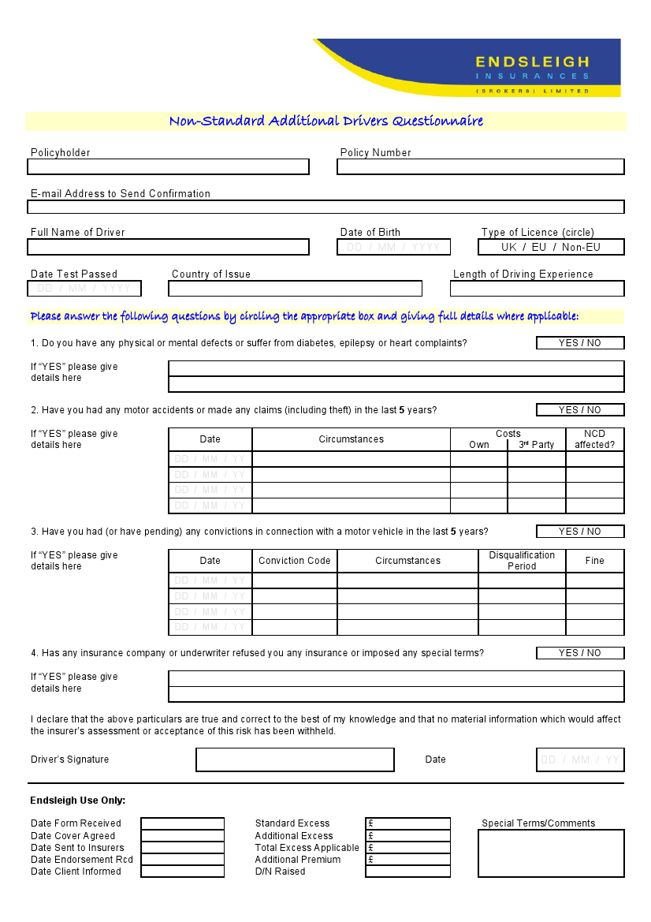

Private Car Registration Form
Please use this form to register a vehicle if you will be using it for Student Activities (sports club & societies). The registration is valid until you cease to be involved in Student Activities, or documents provided become out of date, and must be completed before the vehicle is used.
Name:

Student Number: |  | Year Course Ends:
Club / Society:

Telephone Number:

Email Address:

Vehicle Make & Model:

Vehicle Registration:

Please print your details clearly, and sign to confirm:
- You have informed your insurance company of your intention to transport students on behalf of the Students’ Union as a volunteer;
- Your vehicle is roadworthy and complies with all current road traffic legislation;
- You will inform the Students’ Union of changes to your details – such as change of address, penalty points or licence; and
- You agree with the Students’ Union holding copies of paperwork relating to your vehicle, and will update them when required.

Signature: Date:

Please return to the Students’ Union Reception or Student Activities Co-ordinator.

Union Staff Use
Tick if copies attached:
- Driving licence – paper and both sides of plastic licence
- Insurance certificate (with expiry date)
- MOT certificate / New car registration form
- Tax disc (close up photo will suffice)

