Societies & Sports Clubs
A quick guide to GSU Health & Safety…

Greenwich Students’ Union is a registered charity, and as such, we are legally responsible for all the activities of our Societies and Sports clubs.
If there is evidence that the risks of these activities have not been sufficiently identified, managed and reduced, then GSU is liable for the damage. This includes damage to people, property and reputation.
This is why it is essential that we work with our Sports clubs and Societies to make sure all activities are risk assessed thoroughly, and that these risk assessments are followed accordingly.
A Risk Assessment is a careful examination of what could cause harm to people/property/reputation, so that organisers and attendees can weigh up whether enough precaution has been taken to prevent this harm from occurring.
Thankfully, GSU have already risk assessed the majority of the regular activities that may take place, including:
- The use of University/SU rooms (where the activity taking place fits the room’s primary purpose)
- Usage of University/SU stalls across campus
- Holding a bake sale (though additional allergy info must be provided for all goods on display)
- Participating in sports fixtures on our Avery Hill campus
You can find these risk assessments within the ‘Resources Hub’ of the student activities committee hub, on the GSU website.

What do Group Leaders need to do, to help us keep our activities and students safe?

When organising a new, unusual or one-off activity for your student group… we need you to help us complete a Risk Assessment.
A number of Risk Assessment templates can be found within the ‘Resources Hub’ of the student activities committee hub, on the GSU website. These should form the basis of your Risk Assessment, to which you should add any extra risks that are specific to the activity you are organising.
If you are unsure what to include, I fully recommend turning to google. Chances are, a similar Risk Assessment will exist, with hazards and precautions that you should look to include.
Once you are happy with your Risk Assessment, send it over to activities@gre.ac.uk, and a member of the activities team will get back to you to approve/amend the document.

When you are working with an external venue/organisation… make sure to ask for a copy of their personal Risk Assessment, and email this over to us. If this is sufficiently clear, we are unlikely to need you to complete a Risk Assessment of your own.
When you are organising an activity that takes place off-campus… we will need you to complete a ‘Trip Attendance List’ and an ‘Itinerary’ (again, found in the resources hub).
The attendance list be complete with the name, student ID and contact telephone number of all who are attending. If you are staying somewhere overnight, we will also require details for an emergency contact of each attendee.
The itinerary for your activity should include details of who/where/when you shall be visiting, and a break down of the activities you are participating in.
When communicating with your members… we request that you give them as much notice and information about your activity as possible. Please make sure they all have an opportunity to see the Risk Assessment/itinerary of the activity, before it takes place.
If you have new members attending, particularly those who are unfamiliar with any key skills involved, we recommend offering them a brief introduction, before the activity takes place.
While your members are ultimately responsible for their own actions, it is your responsibility to ensure that all safety guidelines and procedures are adhered to. If you haven’t followed the precautions stated in your Risk Assessment, legally, that is essentially the same as having no precaution in place at all.
When organising an activity that includes the consumption of alcohol… this must be mentioned within your Risk Assessment. It is important to be aware that alcohol is often a high-risk factor to many medical emergencies, damages and acts of ill behaviour.
To ensure minimal harm occurs, a member(s) of the committee should place themselves in a responsible and sober position/role throughout the activity.
Please remember that GSU activities should be accessible to all members of the University community, and that many students may feel excluded from your group should your activities consistently involve the consumption of alcohol.
When something goes wrong… please make sure to let us know as soon as possible. By law any accident, however minor, must be reported to the Students’ Union within 24 hours.
If the activity has taken place on or near to campus, contact campus security, and then ensure to report it to the University, via the student portal on the UoG website: gre.ac.uk/about-us/governance/safety
When your activity has ended… make sure to review and evaluate the success of the activity and the accuracy of your risk assessment/itinerary. Make any amendments there and then, to make sure they are not forgotten during any future planning.
Trips
Any time your group goes off campus (excluding sports fixtures) it counts as a trip. If you are planning a trip please fill out the event proposal form at least 1 month in advance greenwichsu.co.uk/activities/handbook/events/eventrequest remembering to include the following information:
- destination
- transport details
- expected numbers
- costs
- dates
- times

Once your form has been received by the activities team, we will be in contact to arrange a meeting to go over the details and help with booking. If it is a trip that requires an overnight stay, all group leaders attending the trip will be required to receive a health and safety briefing.

External Venues
If you are using an external venue, please still complete the Events Form, as it is important that this information is shared with us. If it is a particularly large event we will likely ask you to come in for a meeting with the Activities Team to discuss the need for the venue and make sure that you have budgeted for all the costs properly.
Health and safety
By law any accident, however minor, must be reported to the Activities Department within 24 hours. If necessary, contact the relevant emergency services on 999 (or the relevant local emergency number if abroad – often this is 112). If you are on campus then Security will do this for you, and ensure that the emergency services have the correct information and that the gatehouse staff are expecting them.
Contact the Students’ Union on 0208 331 7629 / 9596 to explain what has happened and get further support. If your trip is taking place outside of the Union opening hours then you should arrange in advance with the Student Activities staff for a Students’ Union staff member to be contactable in case of an emergency.
High risk or outdoor pursuit activities must have an additional set of procedures to deal with the emergencies that are specific to their activity. This information should be communicated to group members via trip or event briefings and any necessary training.
It is the responsibility of the activity committee, trip leader and vehicle driver to ensure that all participants are aware of the actions to take in the event of an emergency.
Accidents must be reported by completing the reporting form found on your University portal.
app.workrite.co.uk/AmsUi/ReportIncident.aspx
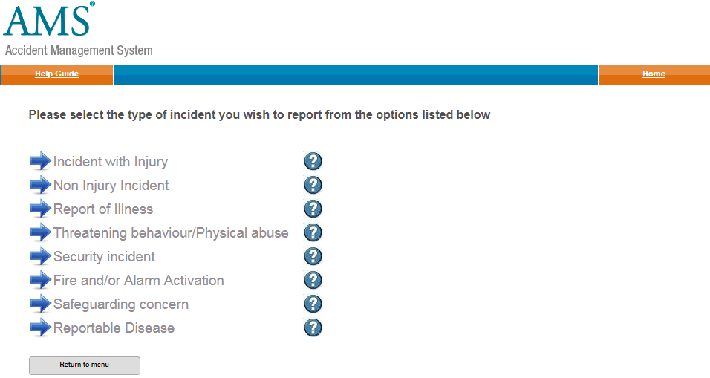
Following a report, an investigation may be undertaken by the Activities Manager or other relevant staff to gain further information about the incident, so please make sure the accident report form is filled in correctly and as fully as possible.

Transport
There are several options for transport for student groups. Please note this section does not deal with transport for sports fixtures.

Remember my fact from earlier…
Greenwich Students’ Union is a registered charity.
As part of that, even though our Sports clubs and Societies are student-led, they are still GSU’s legal responsibility!
As such, it is essential that the risk attached to our activities is managed as thoroughly as possible.
Well, GSU are liable for the damage, if there is evidence that we haven’t assessed the risk and reduced it accordingly.
Same thing goes if a Society ends up giving all of our student data over to the mafia. If it was one of our student groups, we’re still liable.
Simply put… a Risk Assessment is a careful examination of what could cause harm to people, so that you can weigh up whether you have taken enough precaution to prevent it from happening.
A number of regular activities have already been risk assessed:
Room Bookings (where activity fits primary room purpose)
Stalls
Bake Sales (though, you still need to provide allergy info)
Sports Fixtures

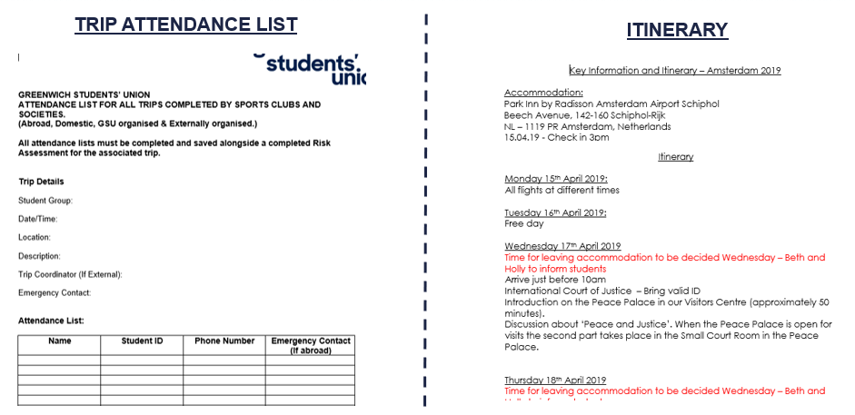

How can I ensure my society is risk assessed?
As a committee member, you have a certain level of responsibility for the actions of your Society and the events that you run.
While individuals are ultimately responsible for their own actions, it is your responsibility to ensure that all safety guidelines and procedures are adhered to.
In the event that something goes wrong, the first thing turned to will be your Risk Assessment – if you haven’t followed the precautions stated, that is essentially the same as having no precautions at all.
Some H&S Top Tips:
Send your risk assessment to participants in advance
Provide an induction to novice members
Put a set of rules/guidelines in place
Review your Activities & RAs regularly
If you’re unsure, google it.
If google can’t help, ask us!!

Events with alcohol consumption
The consumption of alcohol can be a high-risk activity, and a contributing factor to many medical emergencies, ill behaviour and damage.
If you are organising an event where alcohol is provided, you must mention this in your Risk Assessment, and inform us accordingly.
To ensure damage is limited, a member(s) of the committee should place themselves in a responsible (sober) position throughout the event.
Please remember, that at no time should a student feel pressurised into drinking – allegations of such behaviour at a society-organized event may result in disciplinary actions.
Let’s not forget, not all members of your group will consume alcohol – a lot of UoG Students don’t - and many more will not do so in excess.
Holding alcoholic socials is totally fine, but be mindful that consistently doing this can be rather off-putting for students.
And once again, alcohol will not be funded from a Society’s own funding.

In the event something goes wrong, please make sure to:
- Let us know!
- Report it via the Student Portal on the UoG Website!!!
gre.ac.uk/about-us/governance/safety

Hey, remember that time I mentioned that GSU is a charity…
Sadly, that means our resources are by no means infinite. Accordingly…
it is imperative that student groups look after their equipment.
We track all the purchases made by our Student Groups, and over the summer, will compile an asset list of all equipment we expect each group to own. This is owned by the UNION, not the Society, and not the committee.
If you have recently purchased long-term equipment, we will not fund any duplicates without asking serious questions.
If you want future member generations to benefit from your Society, don’t break your stuff. Simple.

