Claim Form: https://forms.gle/EsuGpAu7mBUSGwME7
Please put the above hyperlink on the below screenshot. Picture will be a resource on the Resources Hub.
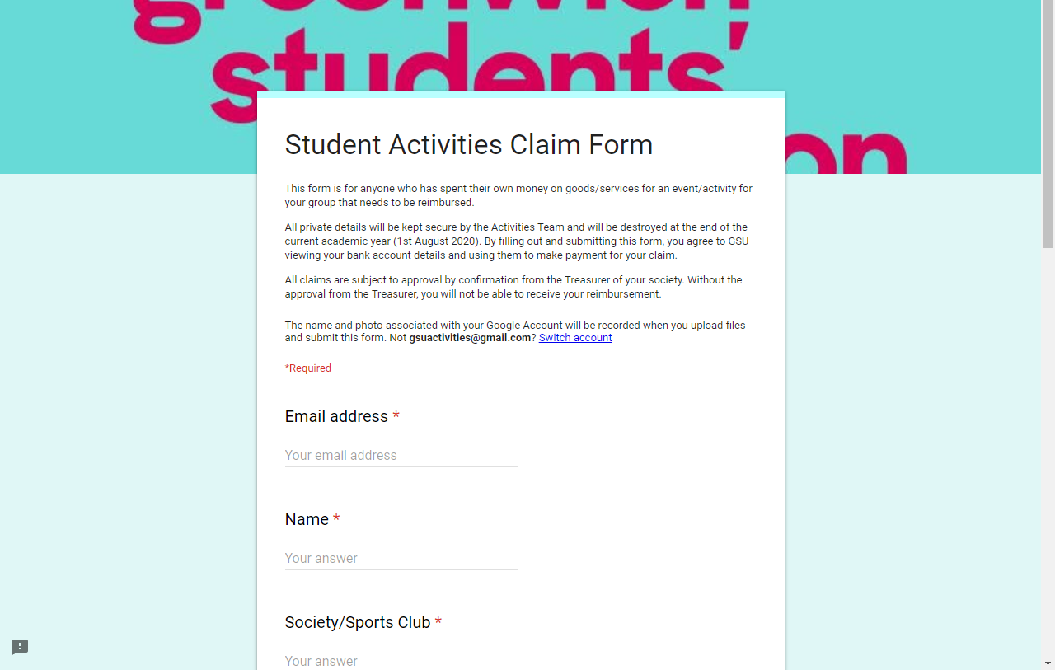
Activities Development Fund: https://forms.gle/cG1C1KMkVVJYGAVH7
Please put the above hyperlink on the below screenshot. Picture will be a resource on the Resources Hub.
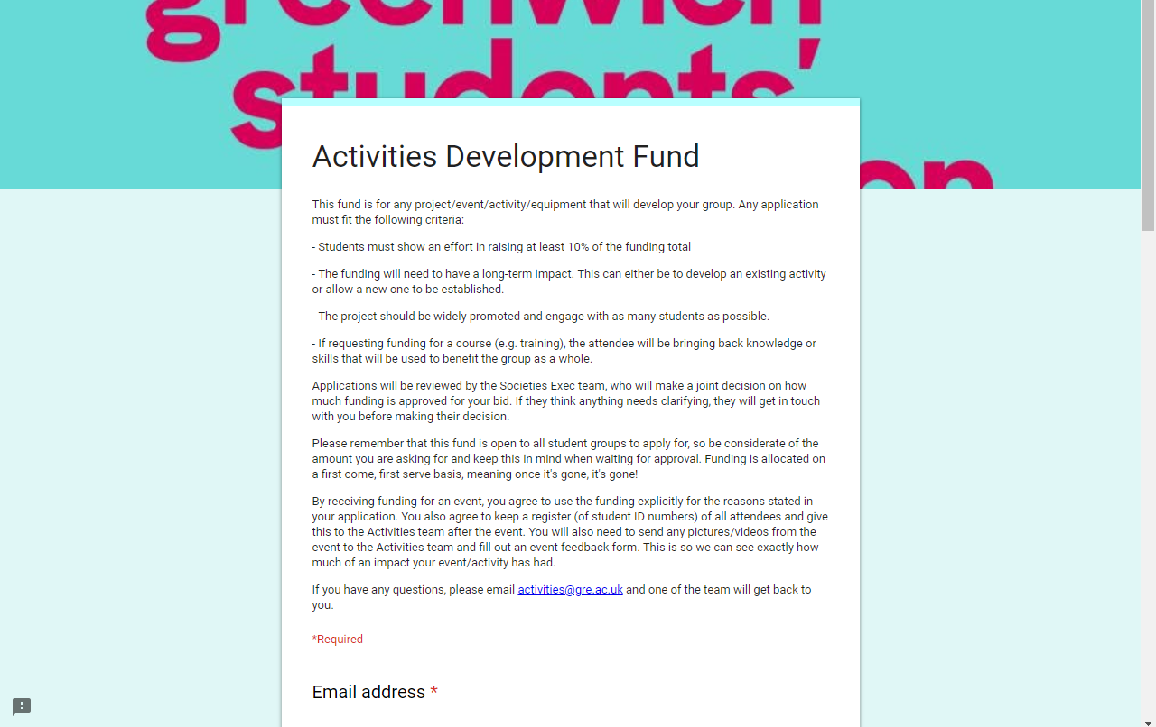
Academic Communities Fund: https://forms.gle/YVeStR6SC6WSRB2d9
Please put the above hyperlink on the below screenshot. Picture will be a resource on the Resources Hub.

