Staff Satisfaction Survey 2018
Summary

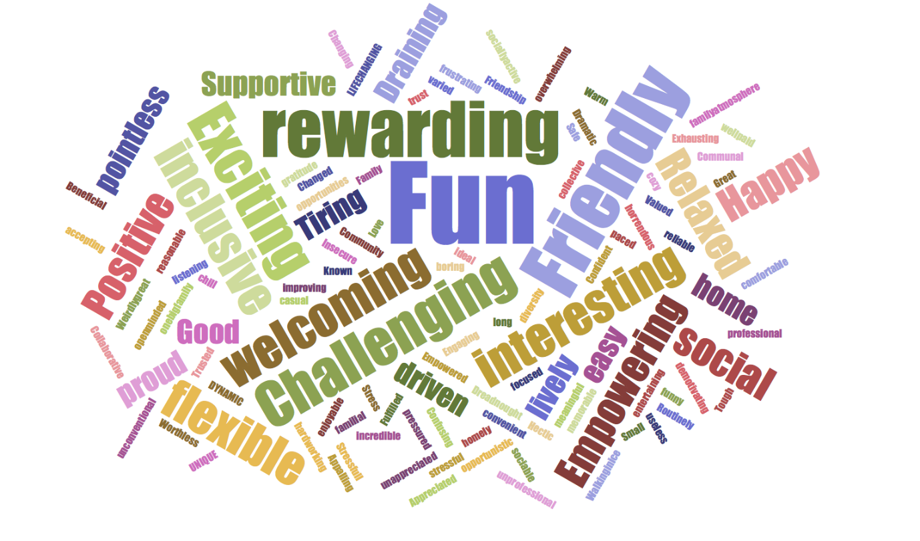

Introduction
A report with all results is available and we can create query reports upon request. The below is a brief summary of the key findings in these results and notes on the factors I believe have affected these key findings.
Demographics of Respondents
- 85 out of a possible 99 career and student staff members completed the 2018 survey
- That’s 54 Student Staff Members and 31 Non-Student (Career) Staff members
- 72% Women and 28% Men; with 9% identifying their gender as different than that assigned at birth
- 72% identify as Heterosexual and 19% as LGBTQ+
- 24% under 21; 60% 21-30; and 16% 31 or over
- 76% White and 14% BAME
- 9% consider themselves as having a disability
The Survey
We ran the survey from the 12th February – 2nd March electing to keep the survey open for an additional week to help gather responses from the Commercial Team. This meant the survey closed on the 9th March 2018.
A series of ranked matrix questions, respondents were asked to what extent they agreed or disagreed with both positively and negatively framed statements focussing on 12 key areas of working:

- Colleagues
- Communication
- Employee Wellbeing
- Engagement
- Leadership
- Learning and Development
- Management
- Performance Management
- Reward
- Role
- Service
- Values

The Results are broken down using a colour coding system that has 4 indicators:
70% or more of respondents Positive and less than 20% of respondents Negative
Between 50 - 70% of respondents Positive and less than 20% Negative
Less than 50% of respondents Positive or 20% - 30% of respondents Negative
30% or more of respondents Negative
Three benchmark comparisons are provided in this report
- Students' Union (SU) Peer Group Benchmark median - The median score amongst your chosen SU benchmark peers
- Students' Union (SU) Whole Sample Benchmark median - The median score amongst all participating SUs
- Third Sector Benchmark median - The median score amongst the Third Sector organisations
The peer group figures are based on data collected from your chosen SU peer group:
- Goldsmiths
- Kings College London SU
- Kingston
- London South Bank
- Queen Mary
- University of the Arts/LSE
- University West London
The Students' Union Whole Sample Benchmark median figures are based on data collected from the 40 SUs which participated in the survey this year:
- Bristol  - Aberystwyth  - Anglia Ruskin  - Art's & LSE SU's  - Beds (Bedfordshire)  - Birmingham City  - Birmingham Guild  - Brighton  - Cardiff  - Durham | - Glasgow Caledonian  - Goldsmiths  - Greenwich  - King's College London  - Keele  - Kingston  - Leeds Beckett  - Leicester  - Lincoln  - Liverpool | - Liverpool Guild  - London South Bank  - Manchester  - Manchester Met  - Middlesex  - Northampton  - Northumbria  - Not Trent  - Nottingham  - Plymouth | - Queen Mary  - Royal holloway  - Salford  - Sheffield  - Strathclyde  - Sunderland  - Sussex  - Ulster  - University of West London  - York St John
The Third Sector Benchmark median figures are based on data collected within the last 2 years from 68 charitable organisations.
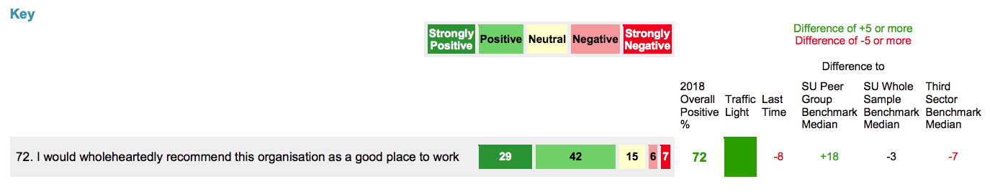
The overall indicator of staff satisfaction is drawn from Q.72, with this result this year:
Key Indicator Summary
This is a Strongly Positive result. When pitched up against our SU peer benchmark for this year we can see how much better our average is than our London SU peers. We are roughly on a par with our wider benchmarking group but fall behind third sector organisations by a small margin. This is an indicator of the challenges SUs face, most especially in London in the present climate but it is also testament to our response to these challenges.
That said we have fallen behind our score from last year and we have been able to identify, upon closer inspection the source of this drop, which I’ll unpack below.

Highlights – Lowlights
Highlights | 2018 Overall Positive % | Traffic Light
58. People here are treated equally irrespective of ethnicity, gender, disability, age, sexual orientation or religion 55 41 1 1 1 | 96
23. I understand the performance standards that are expected of me 42 51 5 2 | 93
59. This organisation values diversity 49 39 11 1 | 88
73. I would willingly put in extra effort in order to help the organisation 41 46 8 5 | 87
70. I feel that my work contributes to the organisation's performance 41 46 8 1 4 | 87

Lowlights | 2018 Overall Positive % | Traffic Light
49. This organisation offers a good benefits package 9 22 42 16 9 | 32
34. This organisation provides people with good prospects for promotion or advancement 11 32 32 18 8 | 42
39. I am worried about job security with this organisation 13 33 21 14 19 | 46
47. I am rewarded fairly in comparison with others in the organisation doing similar work 13 35 34 12 6 | 48
46. I am rewarded fairly for the contribution I make in my particular job 13 35 31 13 8 | 48
Highlight/Lowlight Summary
When compared to last year we learn firstly that both our highlights and lowlights have lower scores this year but only by factors of 2 or 3%. Q.58, (Q57 in 2017) is once again our highest score and similarly Q.23 and Q.73 are also ranked in the highlights. The SUs demography supports an increase in diversity over the last year and this is recognised here. New to the highlights this year is Q.70. I think this can be put down to the core messaging surrounding the Big Plan and the integral part consultation played in its construction.
The lowlights, despite the overhaul of our HR policies and internal communication pieces, focus in on reward. Whilst I think it’s fair to say that very few members of staff will consider their salary enough the lowest score, focussing on benefits rather than salary, is probably more to do with internal communication, than the actual benefits. The lowness of the score for Q.49 is due to a large Neutral response. Rather than passing judgement on the benefits it’s indicating that not enough has been done to communicate these benefits. Given the number of meetings held with career staff focussing on this package, the consultations held as a part of the HR etc, this seems difficult to believe. When you isolate the data for Career Staff only the response is a Blue 52, with weighting in favour of positive but still with a large neutral set. This is better but may indicate the need (as happened at the last staff day) for further unpacking for career staff.
When you look at the same results for Student Staff (most of whom are on zero hour contracts and have had some existing benefits removed) the result is a Red 20. This is the same pattern with Q.39 which is low for Career Staff at Orange 52 but even lower for Student Staff at Red 43. This brings us to the abiding theme for this year’s results.
Student Staff vs Career Staff Results
There is a marked downward trend on Student Staff satisfaction this year, which can be seen throughout the results. As an example we have the Key Indicator for satisfaction Q.72. Career Staff responded with a Green 81 which is 23% higher than last year. The Student Staff responded with a Blue 67 a coincidental 23% drop from their score last year.
This trend is most prevalent in the Performance Management and Reward sections with the highest drop in percentage points (a fall of 40%) from last year in Q.26 “I receive regular feedback and thanks for doing good work” scoring Red 39 compared to Career Staff scoring Green 74.
The following is a note from my and members of SLT’s observations rather than directly linked to the survey:
The largest contingent of Student Staff is from the Commercial Team and there are a set of circumstances that would have affected this level of dissatisfaction. In brief, the comparison to last year’s results is skewed by some demographic factors. Last year’s students were predominantly 3rd years, used to working conditions, more familiar with their roles and the management team and had no expectations or resulting anxiety about future employment. This year the students are mostly second years and the impending move to Dreadnought and abiding rumours surrounding the future of Sparrows Bar has made the future of employment a genuine concern. Furthermore the Commercial Team has had to clamp down on the number of shifts available and take a firmer control over processes due to firefighting a number of procedural irregularities.
Couple these factors with the fact that we needed to extend the survey’s timeline by a week due to a lack of responses from the Commercial Team and the resulting pressure put upon staff to fill it in. This may have further affected the mood of those taking the survey at that time.
The picture is clear enough that while we have had external factors impact the student staff responses the performance management procedures, put in place as a part of the Big Plan, have had little effect and this can be put down to the continued trouble the Commercial Team have had at making time, setting aside budget for, 1-1s or performance reviews.
Comparisons to Last Year
Departmental Shifts
The biggest shift (and most positive) within departments is in Membership Services Department. Ironically this is perhaps best represented by looking at the number of Negative responses. In 2017 62% of responses were Negative (with 28% Red), in 2018 just 11% of responses were negative (with only 1% Red). This is compounded by an increase in Strongly Positive responses of 74% Green.
This staggering improvement can be attributed to the investment put into the department over the last year. Supported by good managers and leadership, the restructuring and increase in human resource for this team has led to higher satisfaction levels, most especially in the Employee Wellbeing and Colleagues sections.
The Support Services Department has not fluctuated much from its positive 82% Green last year to 84% this year, though it should be noted that Support Services has had no Red responses at all this year compared to two last year.
The Commercial Department’s satisfaction level has fallen this year with 38% Negative responses compared to 5% last year. This is compounded by a dramatic decrease in Strongly Positive responses from 76% last year to 29% Green this year.
However when isolating the Career Staff this satisfaction level increases exponentially to 78% Green. This underlines the impact of dissatisfaction felt by Student Staff in this department on the whole organisation’s results.
Highest relative to last time | 2018 Overall Positive % | Traffic Light | Last Time
76. I would like to still be working for this organisation in 12 months’ time 38 34 12 9 7 | 72 |  | +13
48. My pay is competitive compared with other similar organisations 16 33 29 15 6 | 49 |  | +8
10. The leadership group creates a compelling vision 18 49 25 6 2 | 67 |  | +6
45. I am able to achieve a good work life balance 31 42 11 14 2 | 73 |  | +5
75. I love working for this organisation 33 38 22 2 5 | 71 |  | +4

Lowest relative to last time | 2018 Overall Positive % | Traffic Light | Last Time
53. Our services are delivered in a cost-effective way 12 40 35 8 5 | 52 |  | -21
16. My manager inspires me to do my best 32 29 22 9 7 | 61 |  | -21
9. I believe that the leadership group are taking us in the right direction 27 35 24 9 5 | 62 |  | -18
8. I trust and respect the leadership group in this organisation 36 33 21 7 2 | 69 |  | -18
30. I am not afraid to openly express my ideas and opinions 29 39 20 7 5 | 68 |  | -17

The lowest scores relative to last time are mainly perception pieces. The aforementioned issues with the student staff and the lack of performance reviews could contribute to a lack of understanding of the bigger picture and the managers/ leadership teams place in the day to day running of an outlet. Finally the pressures on Commercial this year may go some way to explain the biggest drop from last year, the cost-effectiveness of our services.
Open Questions Themes
What is the best thing about working for this organisation?

The main theme here are the staff themselves. Most people feel positive about working with enthusiastic, fun teams. The social side is positive:
“The warmth of the people that work here.”
“The other student staff that work here.”
“Friendly environment and nice staff”
The secondary theme is the values of working for a charity aiming to make change:
“Seeing the difference you make, in action”
“To be able to see change that you inspired.”
“When you can see the impact of your vision and ideas coming to life and positively affecting students.”
The final theme is the flexibility available to, predominantly student staff:
“The organisation is flexible and reacts to staff needs”
“Flexible hours. Working whenever you’re available and it doesn’t matter if you’re not available one week. It’s great not having set shifts that we would work every week.”

What one thing would you change about working for this organisation?

The two abiding themes here are internal communication and the need for more resources:
“For others in the organisation to understand that everyone has heavy workloads and it is not just yourself that is busy and to appreciate this when planning and communicating with others. “
“- better communication between teams and departments”
“More transparent communication rather than rumours, including with decisions made by senior management.”
“Having more resource (people, money)”
“More hours and more events”
“Higher pay.”
Do you feel that the SU is equipping you with skills for your future employability? If so, in what areas, such as customer service, admin etc.

56 respondents stated that they felt they were being equipped for future employment with 11 saying they did not. The majority of skills highlighted focused on Customer Services and Leadership & Management.

How could your elected full time Officers become even better?
The only major theme here was a desired increase in interaction with students and staff:
“I would like to see the officers interact more with students. Most of them seem to be behind their desk doing work. This is due to their high workload.”
“Speak to students more”
“Ask us for our feedback more often.”
“Actually listen to what the staff are saying and the feedback we are giving and then acting on it instead of pretending to care and then do nothing change things or make the environment and the bar better.”
Conclusion
This is still a strongly positive picture. The Career Staff shift, most especially in Membership Services and the growth of staff in that department, have contributed to many high satisfaction scores. The Support Services Teams are equally strongly positive in most sectors. The Commercial scores are down from last year but even here when we isolate the career staff it is a middling to positive set of responses.
This increase in overall Career Staff satisfaction is what has balanced out a predominantly negative response from the Student Staff, most crucially in our largest department for this role.
Recommendations
As such I believe that
- firming up internal communication,
- implementing the current plan to have more regular performance management for student staff,
- and promoting not just the availability of staff benefits but a culture that celebrates what we are able to make available to staff
we can address the areas that are still Orange or Blue.
As for the only truly poor Red score (when looking at the overall organisation results), surrounding job security, there is an issue here that may need to be addressed.
The following is a note from my observations, rather than directly linked with the survey:
It’s true that the uncertainty surrounding outlets has led to a very low score from Student Staff. However we’ve found ourselves in an environment that implies the most recent turnover of Career Staff has not, in the main, been due to the leaving individual’s career progression or development but rather as a “solution” to problems.
This environment is in part fuelled by inevitable communication with leavers who express these sentiments but it is confirmed with the low score this section received compared to last year and to our peer groups. Concerns of this sort are still occasionally eluded to by career staff. I believe that settling in to Dreadnought and a more conclusive set of cycles for our HR policies (which have not yet completed one full year) will help with these issues. Furthermore the training and development aspects of the Big Plan should be entering a more focussed phase as we move into year two and this should help not only with performance but also build confidence in the team as a whole.

